***: Hackathon Day 5 :***

*Objective :*

*"Thoroughly test all components of 'My Marketplace,' optimize performance, and refine backend integrations to ensure a smooth, error-free user experience that can efficiently handle customer-facing traffic during deployment."*

***“Functional Testing of a General E-Commerce Platform"***

***Products listing :***

*• Display of rental items (images, descriptions, prices, availability).*

*• Test filtering and sorting options (e.g., category, price range, location).*

*• Validate search functionality with keywords.*

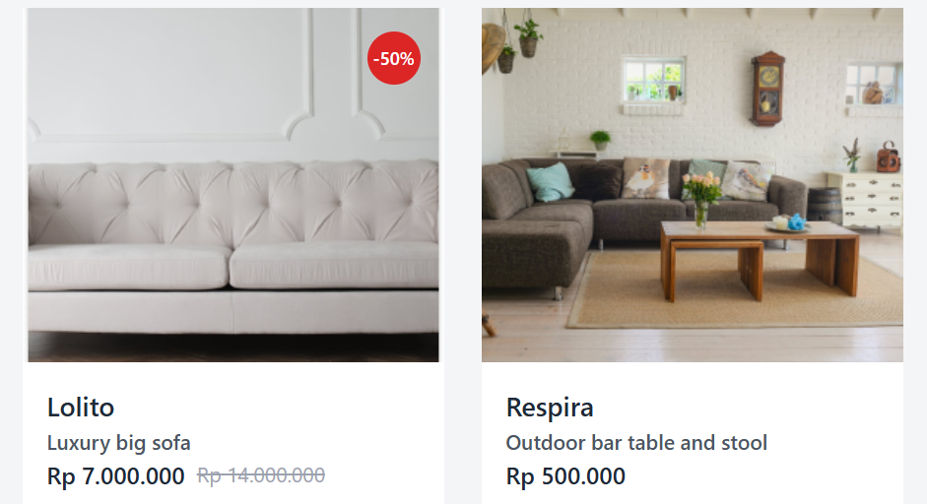

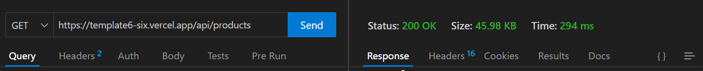

| ***Test Case ID*** | ***Test Case Description*** | ***Test Steps*** | ***Expected Result*** | ***Actual Result*** | ***Status*** | ***Severity Level*** | ***Assigned To*** | ***Remarks*** | |
| --- | --- | --- | --- | --- | --- | --- | --- | --- | --- |
| *2* | *TC001* | *Validate product listing page* | *Open product page > Verify products* | *Products displayed correctly* | *Products displayed correctly* | *Passed* | *Low* | *-* | *No issues found* |
| *3* | *TC002* | *Test API error handling* | *Disconnect API > Refresh page* | *Show fallback UI with error message* | *Error message shown* | *Passed* | *Medium* | *-* | *Handled gracefully* |
| *4* | *TC003* | *Check cart functionality* | *Add product to cart > Verify cart contents* | *Cart updates with added product* | *Cart updates as expected* | *Passed* | *High* | *-* | *Works as expected* |
| *5* | *TC004* | *Ensure responsiveness on mobile* | *Resize browser window > Check layout* | *Layout adjusts properly to screen size* | *Responsive layout working as intended* | *Passed* | *Medium* | *-* | *Test successful* |
|  |  |  |  |  |  |  |  |  |  |

*: Performance Optimization :*

* ***INSTALLATION PROCESS :***
* npm install –g lighthouse
* lighthouse http://localhost:3000 –view

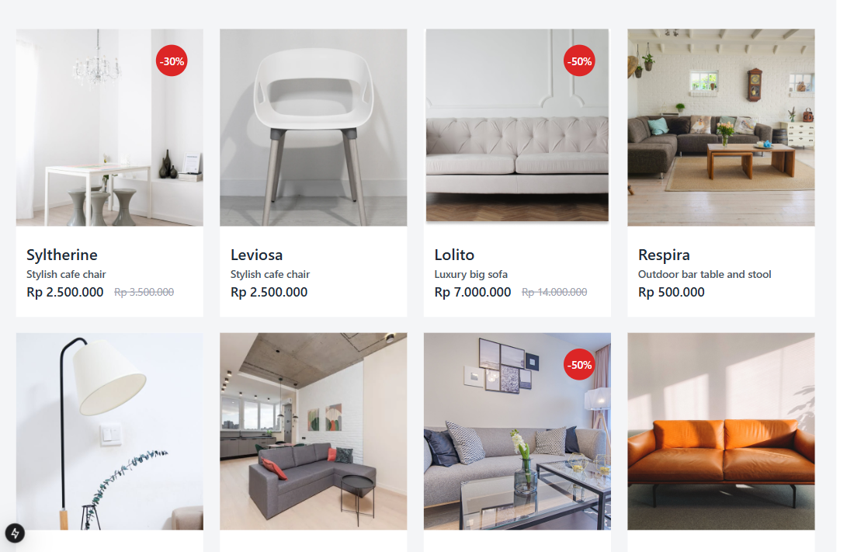 ***DESKTOP :***

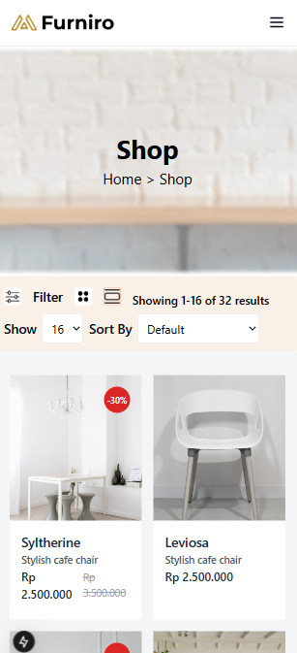***MOBILE:***

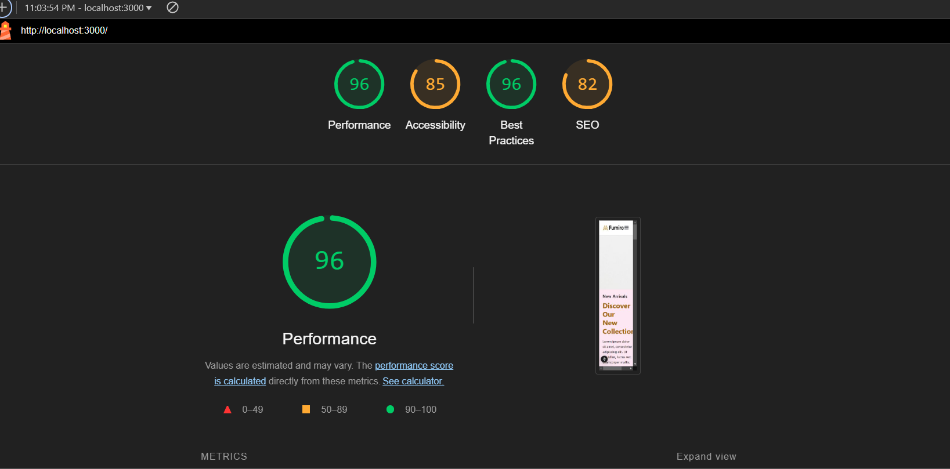

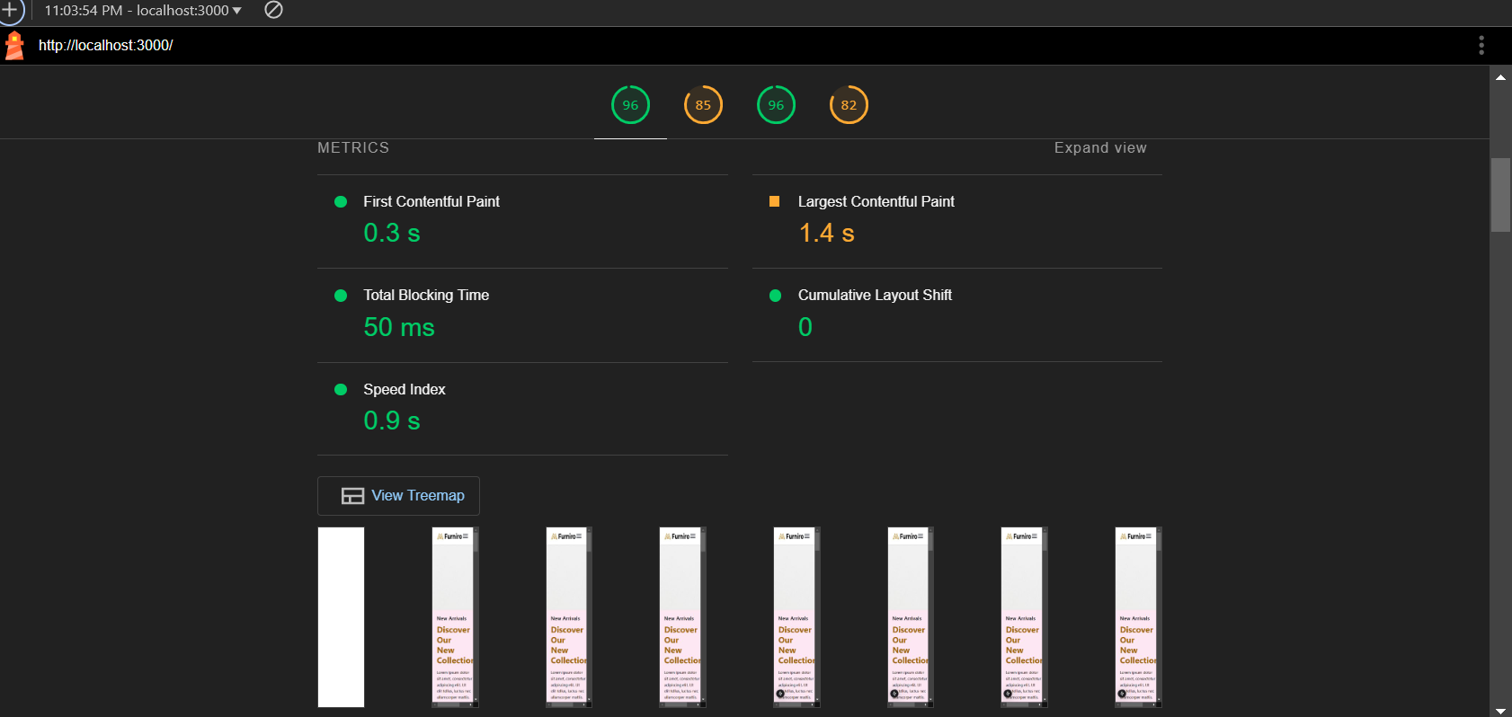

\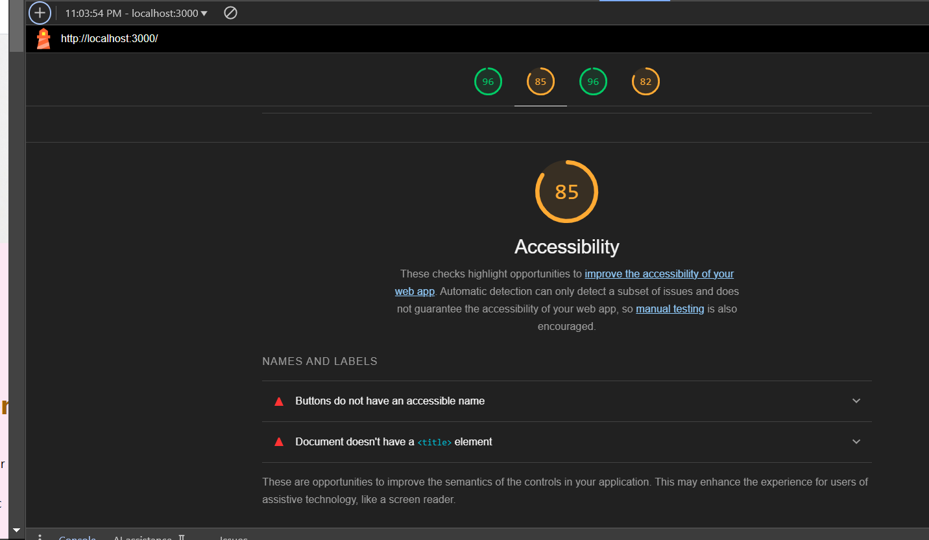

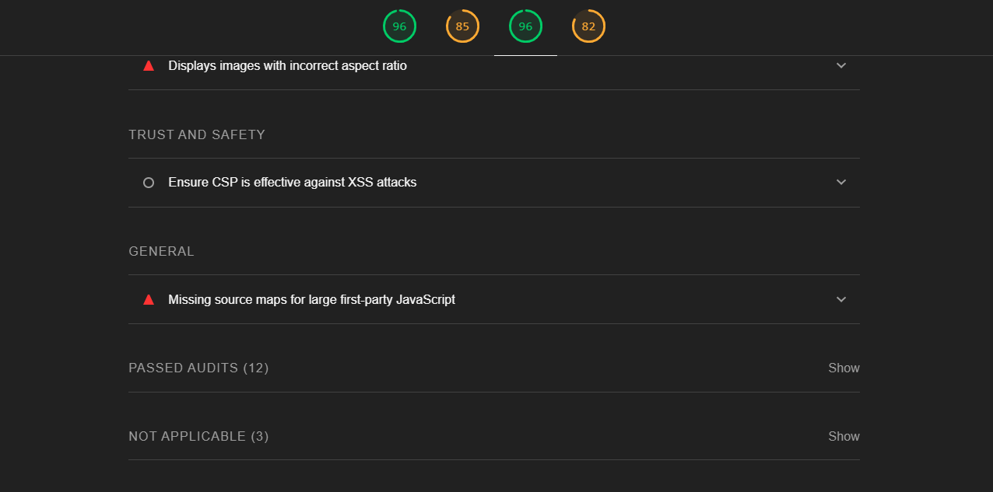

Trust and Safety

Ensure CSP is effective against XSS attacks

|  |  |  |
| --- | --- | --- |
|  |  |  |

General

Missing source maps for large first-party JavaScript

|  |  |
| --- | --- |
|  |  |
|  |  |
|  |  |
|  |  |
|  |  |
|  |  |
|  |  |
|  |  |
|  |  |
|  |  |
|  |  |
|  |  |
|  |  |
|  |  |
|  |  |
|  |  |
|  |  |
|  |  |
|  |  |
|  |  |
|  |  |
|  |  |
|  |  |
|  |  |
|  |  |
|  |  |

**DEVELOPER RESOURCES:**

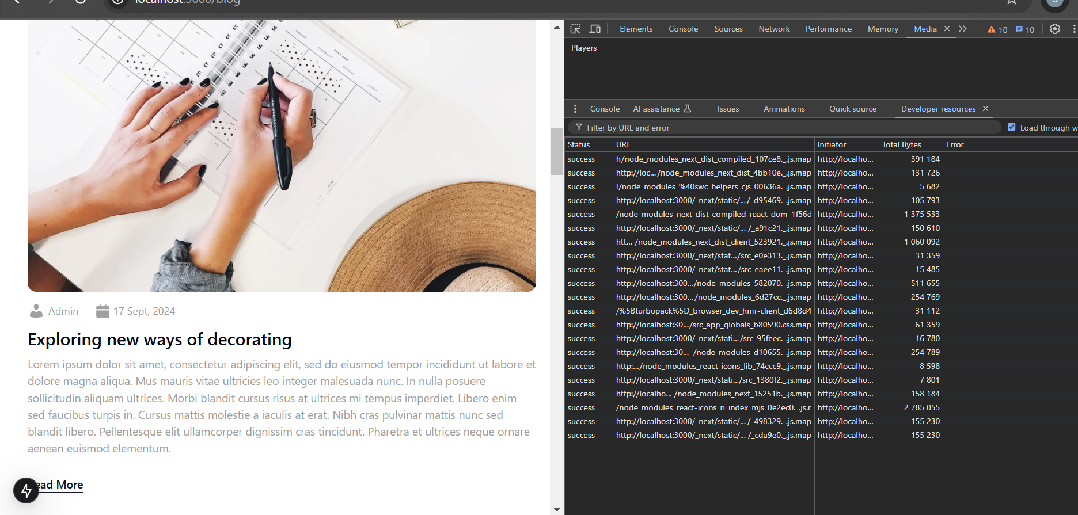

***PERFORMANCE MONITOR:***

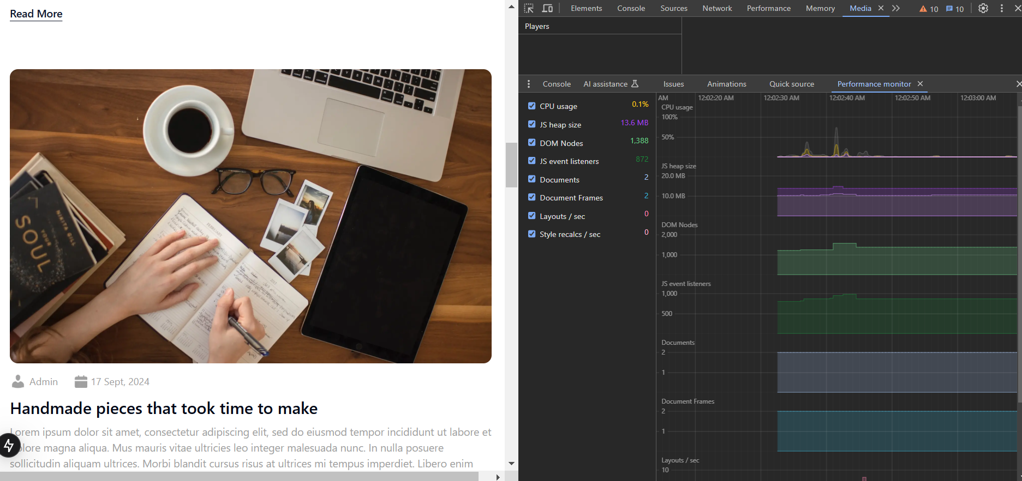

***ISSUES:***

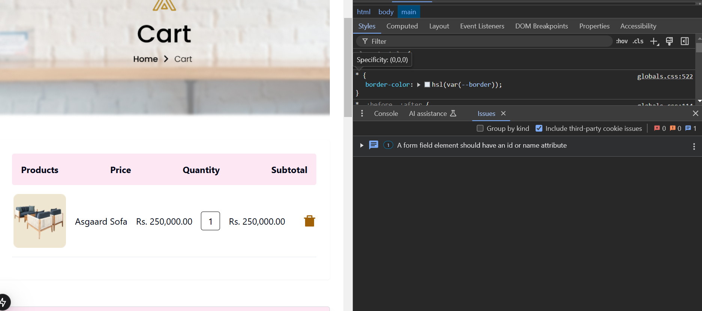

***SECURITY:***

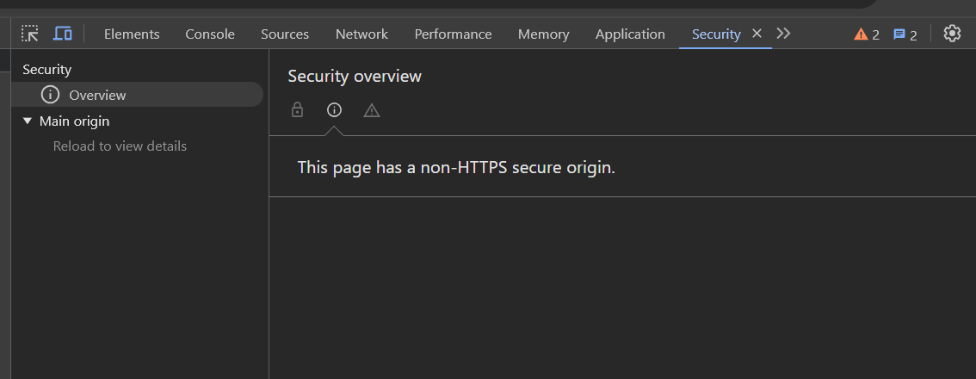

***QUICK SOURCE:***

